**Contents**

**Introduction 3**

**Electrical Detailed Design 3**

Area of illumination 3

Light source 4

Photovoltaics (PV) Panels Required 4

Battery Sizing 5

Bill of Materials (BOM) 6

Limitations 7

**High-Level Design 8**

Functional Block Diagram 8

Schematic Circuit Diagram 8

Mechanical Diagram 9

Software Flowchart 9

**References 10**

# Introduction

This project aims to design a streetlamp that is to be installed in an offshore remote island with limited access to electric power grids. The streetlamp must be run on renewable energy, and thus it is solar-powered.

# Electrical Detailed Design

## Area of illumination

To calculate the area of illumination of a streetlamp, it is assumed that the average height of a streetlamp is 5 m. According to lighting pole spacing guidelines from the [Land Transport Authority (LTA)](https://onemotoring.lta.gov.sg/content/dam/onemotoring/Driving/Road_Safety/LTA_Streetlighting_Guidelines-05Apr19.pdf) (Chin, 2019), the streetlamps should be spaced 12.5 m apart.

To ensure that the distance between two street lamps is illuminated, the radius of beam spread should be minimally 6.25 m (half the distance between street lamps) to ensure that all area of the road remains illuminated at all times.

The angle between the direction of maximum light intensity and the downward vertical axis is taken to be [60°](https://www.mklights.com/BLOGS/standard-for-lighting-design-of-urban-road.html) (MKlights, n.d.). Since this is half of the beam spread, the total beam angle of the streetlamp is 120°.

Fig 1.0: [Total Beam Spread Formula](https://www.totaltracklighting.com/calculate-beam-spread-of-light.html)

From Fig 1.0, the formula to calculate the radius of beam spread (R) is

R $= d×tan(\frac{A}{2})$

Thus, the total beam spread (A) is:

$$A= π{(5tan⁡(\frac{120°}{2}))}^{2} ≈235.619 m^{2}$$

## Light source

As light emitting diodes (LED) are 80% more efficient than other alternatives such as fluorescent or incandescent bulbs, they are used as the light source for the streetlamp. Based on the guidelines recommended by [LTA](https://onemotoring.lta.gov.sg/content/dam/onemotoring/Driving/Road_Safety/LTA_Streetlighting_Guidelines-05Apr19.pdf), the streetlamp should provide at least 10 lux of illumination. (Chin, 2019) Thus, the total amount of illumination (in lm) provided by the streetlamp should be:

$$Total lumens =10 lux× A=10×235.619=2356.19 lm$$

For a good performance LED, its luminous efficiency is roughly 100 lm/W. Thus the power demand for the streetlamp is:

$$Power Demand=\frac{2356.19}{100}=23.56 W$$

Since the wattage of a common neutral (whiteish) LED is 10W, the least number of LED required is:

$$Least number of LEDs= \frac{23.56}{10} ≈ 3$$

Therefore, to provide sufficient illumination, the streetlamp should have at least three 10W LEDs.

## Photovoltaics (PV) Panels Required

To ensure that the streetlamp could last for two consecutive nights (each lasting 10h) without charging, the energy required is:

$$Energy Required=23.56×10×2=471.238 Wh$$

Assuming that the irradiance in rural areas is approximately 1000 W/m2  and the area of one PV panel is 1 m2, the power input for the panels would be:

$$Power input= 1000×1=1000 W$$

As the efficiency of the system is assumed to be 80% and efficiency of the PV panels is 20%, the power output for the panels is:

$$Power output=1000×0.2×0.8=160 W$$

Assuming that the PV cells only charged during the peak sun hour (PSH) of approximately 4 hours per day, the energy output of the PV panel is:

$$Energy output=160×4=640 Wh$$

Therefore, the minimum number of PV cells to meet the electrical standards is:

$$Least number of PV cells required= \frac{471.238}{640} ≈1$$

A Maximum Power Point Tracking (MPPT) system is also used to ensure that the PV panels charge at Maximum Power Point (MPP) to ensure maximum efficiency.

## Battery Sizing

There are four main types of battery technology that pair with residential solar systems, namely Lead-acid batteries, Lithium-ion batteries, Nickel-based batteries, and Flow batteries. While lithium-ion batteries are commonly chosen due to their higher energy density and minimal maintenance cost, they tend to overheat quickly over long periods of usage. Hence, a lithium-iron-phosphate (LiFePO4) battery model was chosen due to its longer cycle life and decreased risk of overheating. (Thompson, 2022) The battery model used for the streetlamp is LiFePO4 Battery 32650. The specifications for the battery are as follows:

Fig 2.0: LiFePO4 Battery 32650

The least number of required batteries from this model is as follows:

$$Least number of batteries=\frac{471.238 ÷ 0.8}{3.2 X 6}≈31$$

The batteries have to be arranged such that each string provides a sufficient output voltage that ensures the total energy stored is minimally 640Wh and not significantly more than this value to prevent overheating. Hence, the considered arrangements were 4S8P and 6S6P

|  |  |
| --- | --- |
| 4S8P configuration $$Total voltage = 3.2×4$$ $=12.8V$ $$Total energy stored = 12.8×6×8$$ $=614.4 Wh$  This falls short of the energy demand (614.4 Wh < 640 Wh) | 6S6P configuration $$Total voltage=3.2×6$$ $=19.2V$ $$Total energy stored=19.2×6×6$$ $=691.2 Wh$  This meets the minimum demand and the excess energy can be stored for days that require a longer operating time with minimal overheating |

Therefore, we need a battery pack of 36 LiFePO4 Batteries arranged in 6S6P arrangement for the streetlamp.

## 

## Bill of Materials (BOM)

|  |  |  |  |  |  |
| --- | --- | --- | --- | --- | --- |
| Part numbers | Description | Unit | Unit cost | Total cost | Source |
| NSL-19M51 | [Light dependent Resistor](https://sg.rs-online.com/web/p/colour-light-sensor-ics/9146710) | 1 | SGD 1.38 | SGD 1.38 | Luna Optoelectronics |
|  | [LED bulb 10W](https://www.fortytwo.sg/philips-led-bulb-10w-e27-4000k-230v.html?msclkid=8e4a68887df718943be00dea9b627562&utm_source=bing&utm_medium=cpc&utm_campaign=Qoltured_Sales_Shopping&utm_term=2328834347478582&utm_content=Qoltured_Sales) | 3 | SGD 6.90 | SGD 20.70 | Philips E27 |
| LiFePo4 32650 | [Battery](https://www.aliexpress.com/item/1005005889017414.html?src=google&aff_fcid=26dcf01d585849caa1ee1643f0d3649b-1700982335318-00487-UneMJZVf&aff_fsk=UneMJZVf&aff_platform=aaf&sk=UneMJZVf&aff_trace_key=26dcf01d585849caa1ee1643f0d3649b-1700982335318-00487-UneMJZVf&terminal_id=d2b0d16022994472afba628f0839619f&afSmartRedirect=y) | 36 | SGD 16.08 | SGD 578.88 |  |
| SCC110030210 | [Solar Charge Converter](https://volts.ca/products/smartsolar-mppt-100-30) | 1 | SGD 172.94 | SGD 172.94 | Victron Energy |
|  | [Photovoltaic Panel](https://www.thesolarera.com/post/cost-of-installing-solar-panels-in-singapore) | 160 watt | SGD  0.75/ watt | SGD 120 | Solar Era |
| HYLFPW12-25 | [Battery Management System](https://www.google.com/url?q=https://www.aliexpress.com/item/3256802937838898.html?gatewayAdapt%3D4itemAdapt%23nav-specification&sa=D&source=docs&ust=1700987763778121&usg=AOvVaw0WF2E0Pq3LTMLbwJTeov9p) | 6 | SGD 248.58/ set | SGD 1491.48 | Vieruodis |
| SK35Y | [DC DC boost converter](https://www.amazon.ca/Adjustable-Automatic-Voltage-Converter-Charging/dp/B0924WW5CL) | 1 | SGD 31.30 | SGD 31.30 | Lufasa |
| Grand total |  |  |  | SGD 2416.68 |  |

The parts above were sourced from various manufacturing companies that work with street lamp manufacturers. The PV panel was sourced from a local supplier instead of a larger company as the overall cost is lower, and the overall module can be customized to better meet consumer needs. Instead of an inverter, a solar charge converter was used as it has an in-built MPPT system and can be managed remotely, minimizing required maintenance checks.

The overall system’s price of $2416.68 falls within the standard price range of solar-powered street lamps ([$1000-$2500](https://www.anethic.com/blog/cost-comparison-of-solar-street-lights-vs-traditional-street-lights)) (Anethic, 2023)

## 

## 

## Limitations

|  |  |  |
| --- | --- | --- |
| Issue | Elaboration | Alternate implementation |
| Excess thermal dissipation due to chosen boost converter system | Model implemented uses the PWM model (1 MOSFET) instead of MPPT (2 MOSFETs).  The MPPT model has higher switching frequency and efficiency which minimizes heat loss | Use a charge converter or inverter with a built-in MPPT model to minimize thermal dissipation |
| Compromised efficiency during inclement weather | During inclement weather the solar irradiance decreases to 800 W/m2 from 1000W/m2, decreasing the harvested power and thus the brightness of the lamp | Increase the battery sizing to store more energy or the efficiency of PV panels by calculating the values using lowest possible irradiance values |
| When turned on the brightness of the lamp cannot be varied | During twilight hours when the lamp needs to be on but not at maximum brightness, power is drained if operated as such, decreasing the battery life | A duty cycle parameter can be implemented into the code to vary the duty cycle of the boost converter proportional to the brightness outside. |
| Momentary instantaneous sources of light could trigger the lamp to switch off temporarily at night | Should any bright source like the headlights of passing lights or any overhead lights be detected by the LDR, it would trigger the lamp to turn off, compromising functionality | A delay can be encoded into the system to check whether the pulse detected is longer than a user-specified amount of time (e.g. 10s) to determine whether it is daylight or another light source. |
| Lack of proper thermal dissipation system | Overheating of the system could compromise efficiency and also pose a safety risk over long periods of operation | LEDs are the components that heat up the most over long usage periods so they could be modified to have heat sinks/fins along them to evenly dissipate heat. |

# High-Level Design

## 

## Functional Block Diagram

## 

## Schematic Circuit Diagram

## Mechanical Diagram

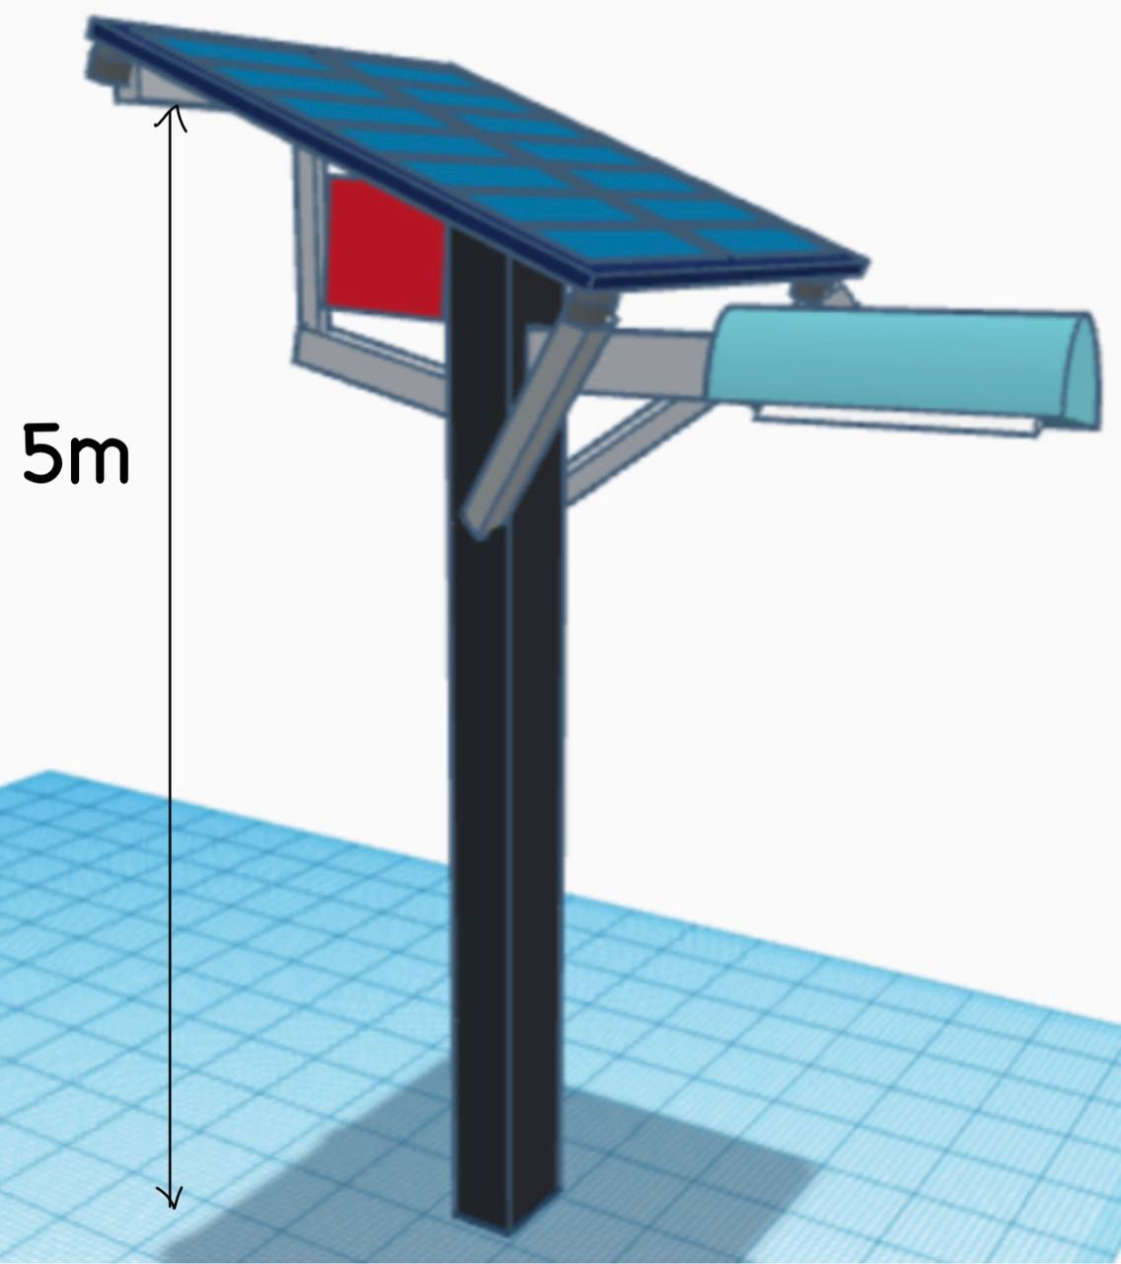

## 

## Software Flowchart

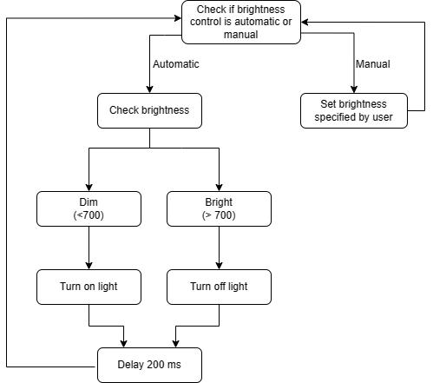

# References

32650 battery. (2022, June 12). ELB Energy Group. <https://www.ecolithiumbattery.com/product/32650-battery/>

Allen, N. (2023, May 15). Solar panel size and weight: A comprehensive guide. Forbes. <https://www.forbes.com/home-improvement/solar/solar-panel-size-weight-guide/#how_big_are_standard_sized_solar_panels_section>

Chin. (2019). LTA Street lighting Guidelines. Land Transport Authority. <https://onemotoring.lta.gov.sg/content/dam/onemotoring/Driving/Road_Safety/LTA_Streetlighting_Guidelines-05Apr19.pdf>

Cost comparison of solar street lights vs traditional street lights. (2023, January 6). Anethic. https://www.anethic.com/blog/cost-comparison-of-solar-street-lights-vs-traditional-street-lights

DC-DC 35W 4A adjustable automatic buck boost power supply module CCCV step UP down voltage converter solar charging. (n.d.). Amazon. Retrieved November 26, 2023, from <https://www.amazon.ca/Adjustable-Automatic-Voltage-Converter-Charging/dp/B0924WW5CL>

Energy efficient Street Lighting Guidelines. (2010, June). <https://niua.in/csc/assets/pdf/key-documents/phase-2/Energy-Green-Building/Energy-Efficient-Street-Lighting-Guidelines-BEE.pdf>

Hyder, Z. (2019, August 7). What is a peak sun hour? What are peak sun hour numbers for your state? Solar Reviews. <https://www.solarreviews.com/blog/peak-sun-hours-explained>

LiFePO4 Lithium Ion Battery BMS Battery Management System. (n.d.). Aliexpress.Com. Retrieved November 26, 2023, from <https://www.aliexpress.com/item/3256802937838898.html?gatewayAdapt=4itemAdapt#nav-specification>

Light bulb beam spread chart. (n.d.). Calculate the Beam Spread of Light. Retrieved November 26, 2023, from <https://www.totaltracklighting.com/calculate-beam-spread-of-light.html>

Michelle. (2020, February 16). Cost of installing solar panels in Singapore. Solar Era. <https://www.thesolarera.com/post/cost-of-installing-solar-panels-in-singapore>

NSL-19M51 luna optoelectronics. (n.d.). RS. Retrieved November 26, 2023, from <https://sg.rs-online.com/web/p/colour-light-sensor-ics/9146710>

Philips LED bulb 10w E27 4000k 230v. (n.d.). FortyTwo. Retrieved November 26, 2023, from [https://www.fortytwo.sg/philips-led-bulb-10w-e27-4000k-230v.html?msclkid=8e4a68887df718943be00dea9b627562&#38;utm_source=bing&#38;utm_medium=cpc&#38;utm_campaign=Qoltured_Sales_Shopping&#38;utm_term=2328834347478582&#38;utm_content=Qoltured_Sales](https://www.fortytwo.sg/philips-led-bulb-10w-e27-4000k-230v.html?msclkid=8e4a68887df718943be00dea9b627562&#38;utm_content=Qoltured_Sales)

Professional, L. L. (2023, April 12). Understanding Luminous Efficacy (lumens per watt) and Its Impact on LED Performance. Lumistrips. <https://www.lumistrips.com/lumistrips-blog/led_efficacy_efficencty_explained/>

Thompson, A. (2022, January 7). AceOn Group. AceOn Group. <https://www.aceongroup.com/news/what-is-the-difference-between-lithium-iron-phosphate-and-lithium-ion-batteries/>

What should be the pole height and distance between poles in street lighting? (2020, October 31). Lighting Equipment Sales. <https://lightingequipmentsales.com/what-should-be-the-pole-height-and-distance-between-poles-in-street-lighting.html>

Victron Energy Smart Solar MPPT 100/30. (n.d.). Volts Energies. Retrieved November 26, 2023, from <https://volts.ca/products/smartsolar-mppt-100-30>

Wattage of LED Bulbs: How Many Watts Does a Light Bulb Use? (2023, November 20). Pick NRG. <https://www.picknrg.com/en/resource-center/led-lightbulb-energy-consumption/>